**RFID-BASED SMART SUPERMARKET BILLING AUTOMATION**

**1. INTRODUCTION**

Shopping mall is a place where people get their daily necessities ranging from food products, clothing electrical appliances etc. Nowadays a number of shopping mall has increased around the globe. Sometimes customers have problem regarding the incomplete information about the product on sale and waste of time at the billing counters. Continuous improvement is required in the traditional billing system to improve the quality of shopping experiences to the customers.

To overcome these problems and to improve existing system, we have designed an RFID based shopping system including bill calculator. This can be done by attaching RFID tags to the products and a RFID reader with a touch panel display at the EXIT gate. With this system, customers will have information about the price of every items that is scanned in, and total price of the item. This system will save the time of customers and man power required in mall and cost associated with the product.

The advent of newer techniques like RFID technology and wireless networks allow the process of shopping at a faster pace, making it more efficient as well as making it more transparent. RFID tags are nothing but small transponders, communicates to a reader wirelessly by transmitting some identifier such as serial number. By construction, they are the special type of wireless cards which carries built-in embedded chip and loop antenna. The chip represents a dual digit card number. The RFID reader circuits generates up to 125 KHz magnetic signal. RFID tags have been widely used to track items and label them in various shopping destinations like supermarkets. They are treated as advanced form of barcode.

In existing system, shopping malls are using barcode standards. The cashier in billing system scans the items using the barcode scanner and gives us the total bill. And the customer can gather the items they want, put it into the container and at the time of billing only. They come to know about the total cost. Hence they need to stand in a larger queue of billing those items.

RFID and barcode are almost similar. They are both data connection technologies that mean it will automatically process the data. However, they differ in many areas. RFID can be read without the line of sight, whereas barcode requires a line of sight to read. Barcode scanner requires a manual tracking, whereas RFID can be automatically tracked. In case of barcode scanner, new information cannot be updated. Whereas in case of RFID, new information can be overwritten.

**2. DESIGN OVERVIEW**

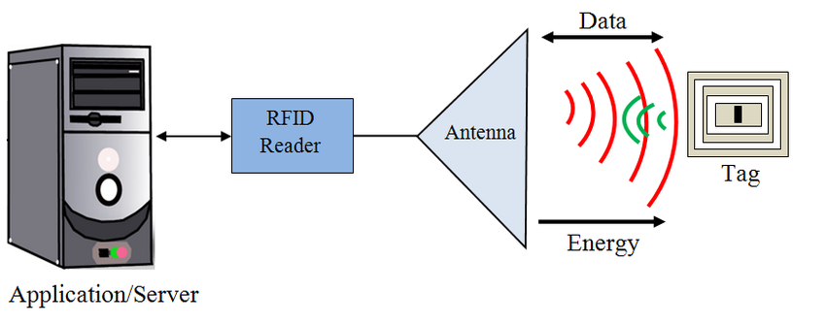

The **block diagram** consists of the following components:

• Power supply

• Arduino-UNO.

• RFID module-(RC522)

• LCD display

• Microcontroller-AT89S52

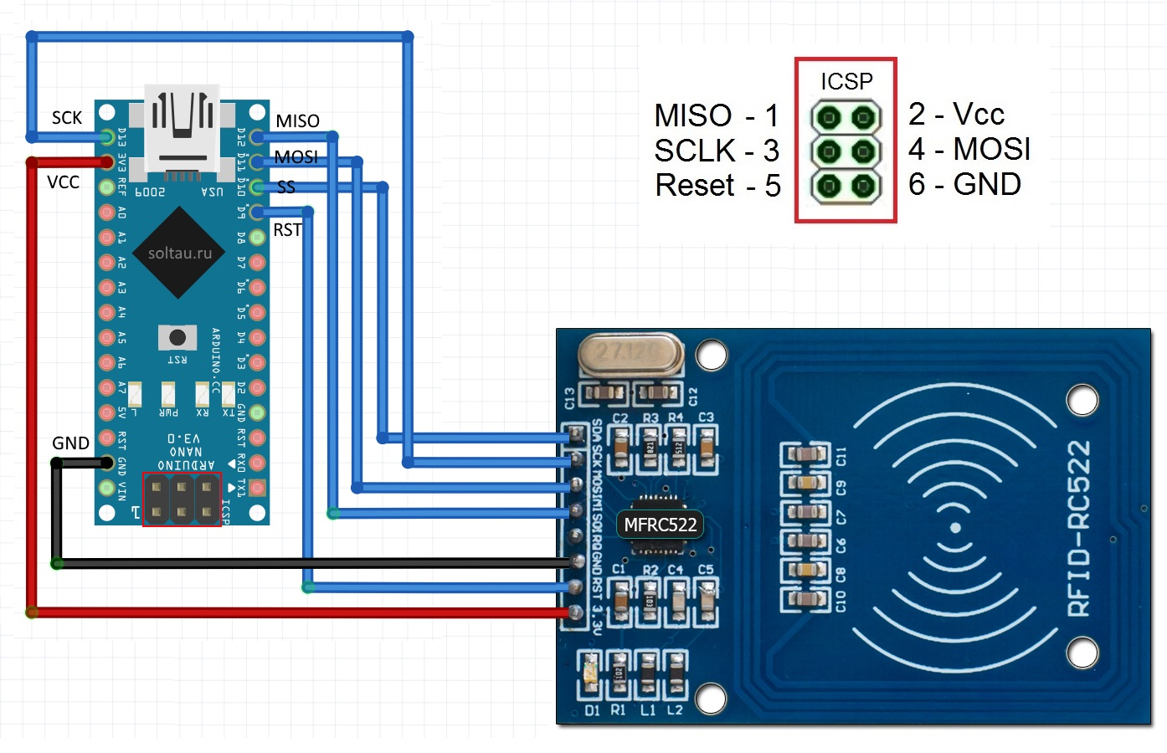

Connection Logic

**2.1 POWER SUPPLY**

The 230v, 50HZ AC mains is stepped down by using a transformer to deliver the secondary output of 12V, 500mA. The output of the transformer is rectified by using a bridge rectifier comprising of four diodes. And the out of the rectifier is filtered by using a capacitor (1000microF). Then it is given to an LM7805 voltage regulator to make a 5V power supply.

**2.2 Arduino-UNO**

**Arduino Uno** is a microcontroller board based on the ATmega328P. It has 14 digital input/output pins (of which 6 can be used as PWM outputs), 6 analog inputs, a 16 MHz quartz crystal, a USB connection, a power jack, an ICSP header and a reset button. It contains everything needed to support the microcontroller; simply connect it to a computer with a USB cable or power it with a AC-to-DC adapter or battery to get started

**2.3 RFID module**

RFID stands for radio frequency identification. Its operating frequency is 125khz. RFID is a technology that uses radio waves to transfer data from an electronic tag called RFID tag or label attached to an object through a reader for the purpose of identifying and tracking the object.

**2.4 LCD DISPLAY**

A 16x2 LCD means it can display 16 characters per line and there are 2 such lines. In this LCD each character is displayed in 5x7 pixel matrix. This LCD has two registers, namely, Command and Data. The command register stores the command instructions given to the LCD. A command is an instruction given to LCD to do a predefined task like initializing it, clearing its screen, setting the cursor position, controlling display etc. The data register stores the data to be displayed on the LCD. The data is the ASCII value of the character to be displayed on the LCD.

**2.5 MICROCONTROLLER**

Here microcontroller AT89S52 is used. The AT89S52 is a low-**power**, high-performance CMOS 8-bit microcontroller with 8K bytes of in-system programmable Flash **memory**. The device is manufactured using Atmel's high-density nonvolatile **memory** technology and is compatible with the industry-standard 80C51 instruction set and pinout.

The various functions of microcontroller are:

* Reading various digital input signals from device.
* Sending this data to LCD so that the person operating this project should understand the status.
* Giving the respective signal to the various output devices.
* Controlling the auto shut gate of the shopping mall.

**(optional components)**

**2.6 ZIGBEE MODULE**

Further additional component. This may be used to add certain features such as **GPS tracking** of products

if we want greater communication level we need ZigBee

ZigBee technology is a standard for data communications with business and consumer devices. It is designed around low power consumption allowing batteries to essentially last forever. The ZigBee standard provides network, security and several application support services. ZigBee is a low cost, low power wireless mesh networking standard. The low cost allows the technology to be widely deployed in wireless control and monitoring applications, the low power-usage allows longer life with smaller batteries and the mesh networking provides higher reliability and larger range.

**3. SOFTWARE DETAILS**

**3.1 EMBEDDED C**

Embedded systems are systems which perform a specific or a pre-defined task. It is the combinations of hardware and software. It is nothing but a computer inside a product. It is a programmable hardware design nothing but an electronic chip. In some cases, a microprocessor may be designed in such way that application software for a particular purpose can be added to the basic software in a second process, after which it is not possible to make further changes Function parameters are always passed by value. Pass-by-reference is simulated in C by explicitly passing pointer values. C program source text is free-format, using the semi colon a statement terminator and curly braces for grouping blocks of statements.

**3.2 Python-MongoDB**

Python can be used in database applications. MongoDB stores data in JSON-like documents, which makes the database very flexible and scalable. The traditional E-commerce shopping can be modelled in MongoDB by using double bookkeeping. When the customer reaches the exit gate they want to bill the products in their cart and we need to perform necessary steps.

3.3 **Arduino IDE**

Based on C language, it is used to configure arduino UNO. The system in which data (RFID tag) is read and respective data is retrieved from database and total price is summed up and displayed on the LCD.

**4. FLOWCHART**

Initialize System

Search for RFID-Tags

**Search for**

**next**

RFID validation

**NO**

**YES**

Read stored information

Display data on LCD after the sum

Store on server.

**In the beginning the system is initialized. Now when the customer picks up all of its items in the cart and reaches to the exit gate then there RFID reader scans for RFID tag under 1 meter. Then the tag is validated. If found, the related data(price) is read from the database and displayed to the customer on the LCD**

**5. ADVANTAGES**

* Reduces man power required at billing counter. This can reduce the expenses incurred by the management.
* Users can be aware of the total bill amount during the time of purchase.
* Safer working condition.
* Reduces time spent at the billing counter and increases customer satisfaction.

**6. FUTURE SCOPE**

* Using a GSM module, we can transfer the bill to mobile instead of printing it.
* Voice assistance can be included.
* Net banking can be included and an app can be developed to pay final bill.
* Robotic ARM can be used for picking and dropping of products.

**7. CONCLUSION**

The progress in science and technology is a nonstop process. New things and new technologies are being invented. As the technology grows day by day, we can imagine about the future in which thing we may occupy every place. Hence this document on RFID based Automated shopping and Billing System describes about purchasing the products with much ease and comfortable, without standing in a queue for long time.

**Team : One-KB**